Teithio – Teacher’s Notes

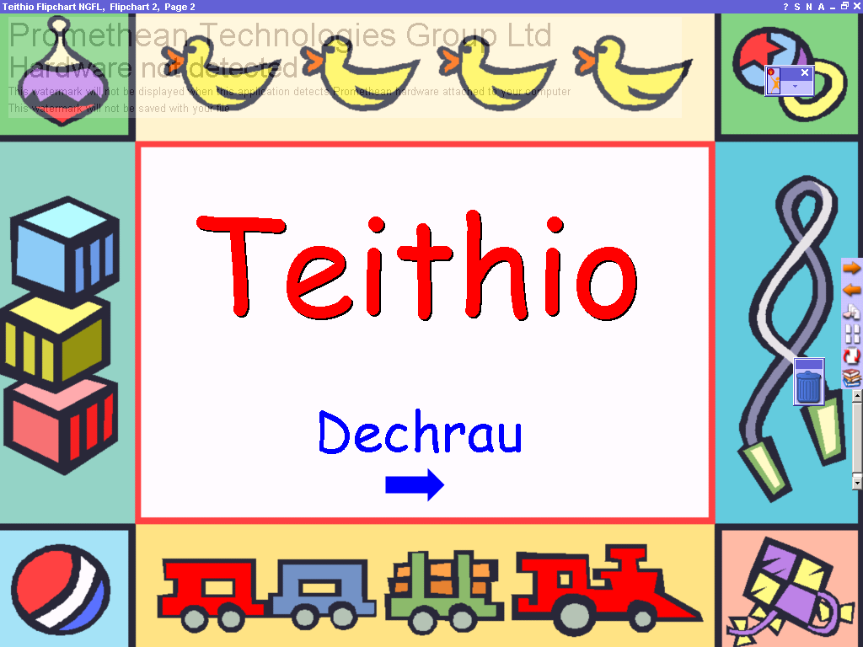
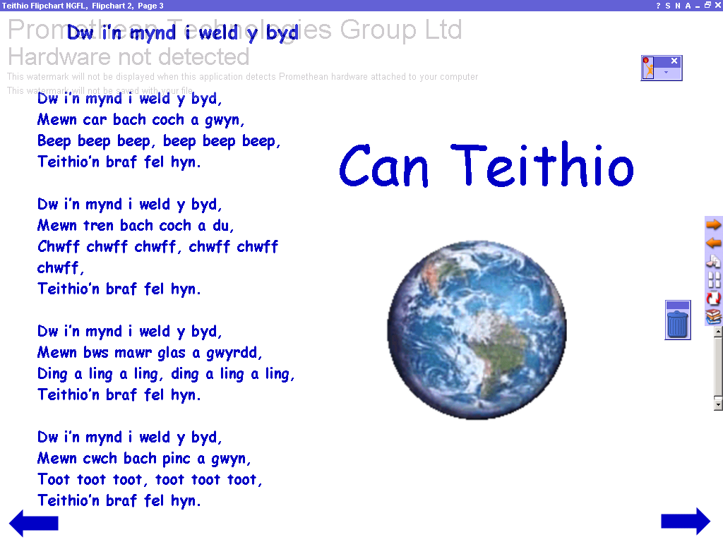
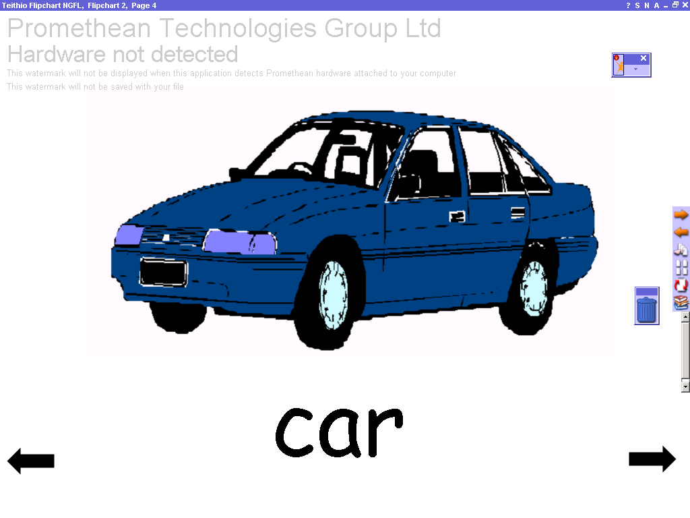
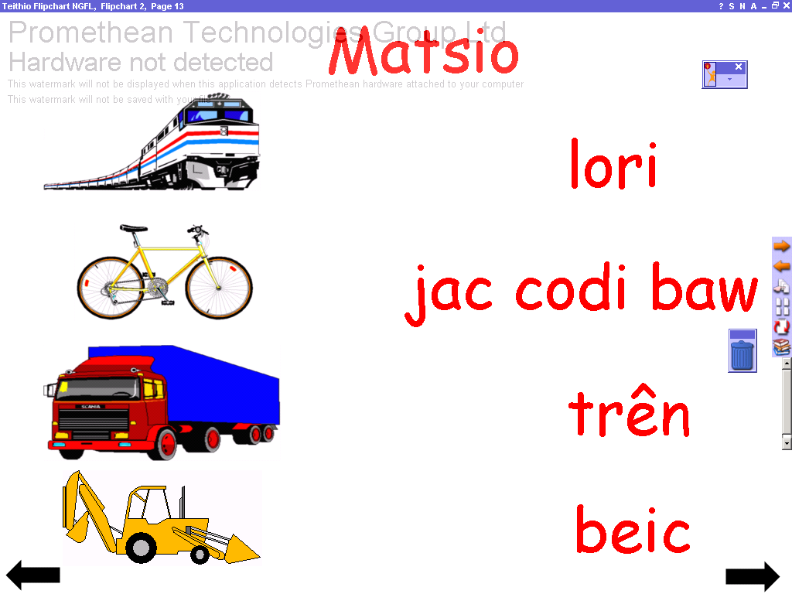
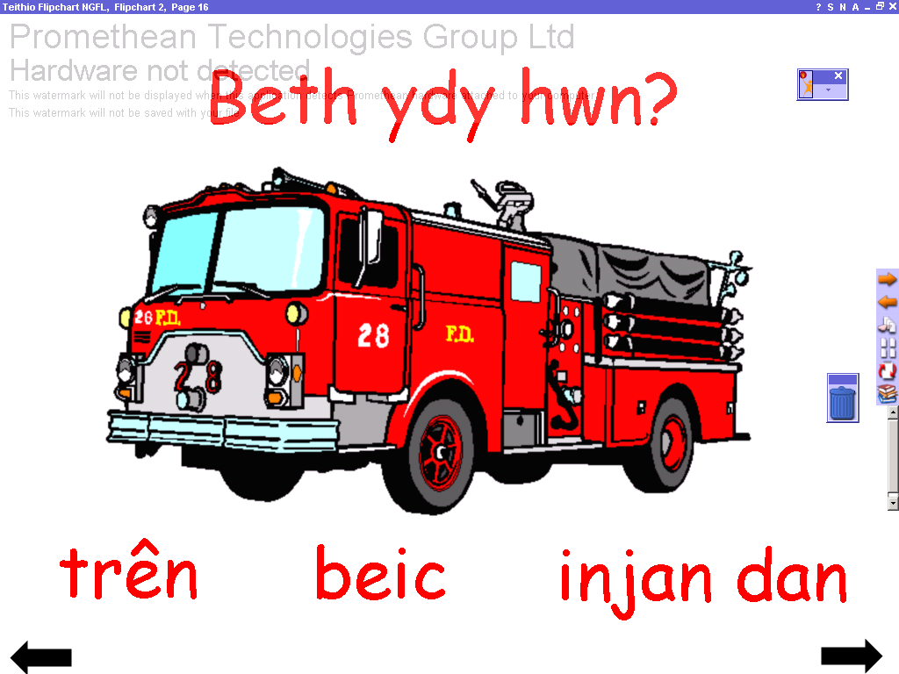
Start page.
Click on the arrows to move forwards and back.

Click on the picture to hear song, ‘Dwi’n Mynd i Weld Y Byd’ (I’m Going to See The World) Song words in Teithio Worksheets folder.

Pages 4 – 12 give Teithio vocabulary. Car, bws, lori, awyren, jac codi baw, trên, llong, beic, injan dân.
Car, bus, lorry, plane, JCB, train, boat, bike, fire engine.)

Pages 13 – 14 are matching pages. Click and drag to match words and pictures. Words or pictures may also be covered.

Pages 15 – 18 introduce question Beth ydy hwn? (What is this?) Click on the answers.

